JupyterHub Instructions

1. Log into Canvas and click on the “JupyterHub” tab.

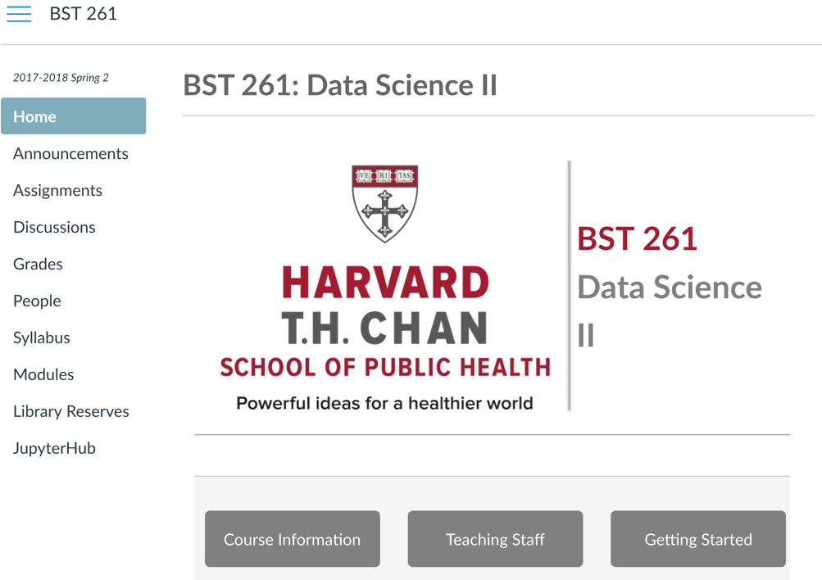

1. Press the “Start My Server” button and wait for up to 2 minutes. You will be taken to a new page.

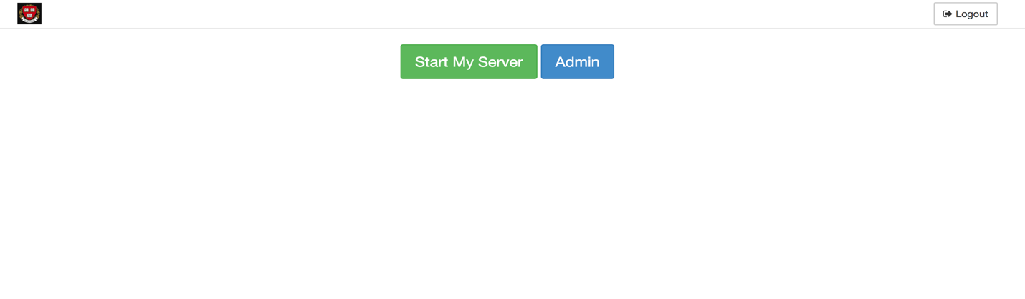

1. It should look something like this and have a jupyter.log file in it.

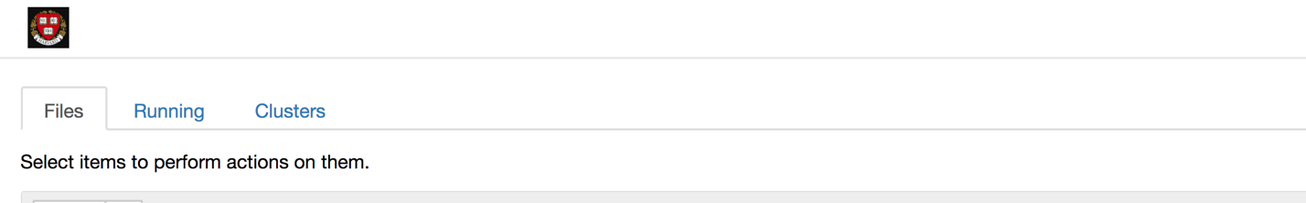

1. On the right side, click on the “New” dropdown menu and select “Terminal”.

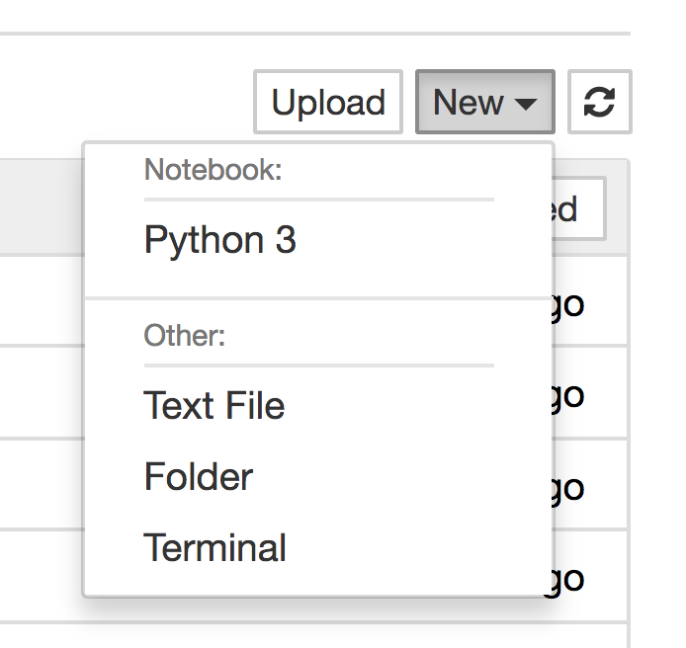

1. Before typing anything into the terminal, go to the course github and copy the repository link. Click on the “Clone or download” button and then the clipboard button. This will copy the link to the repository.

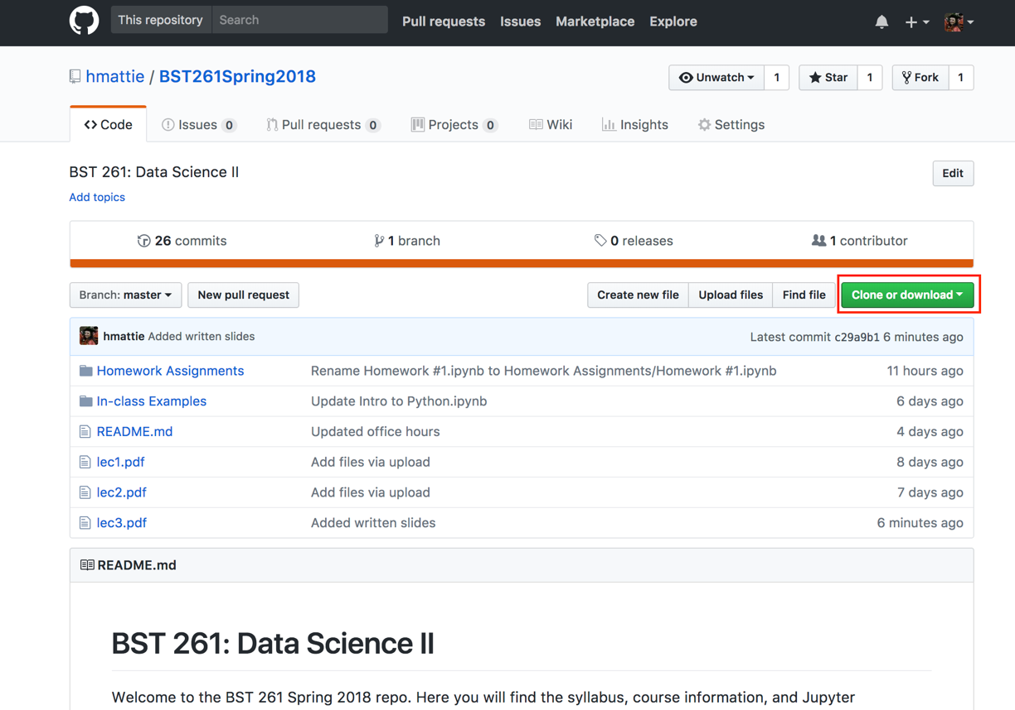

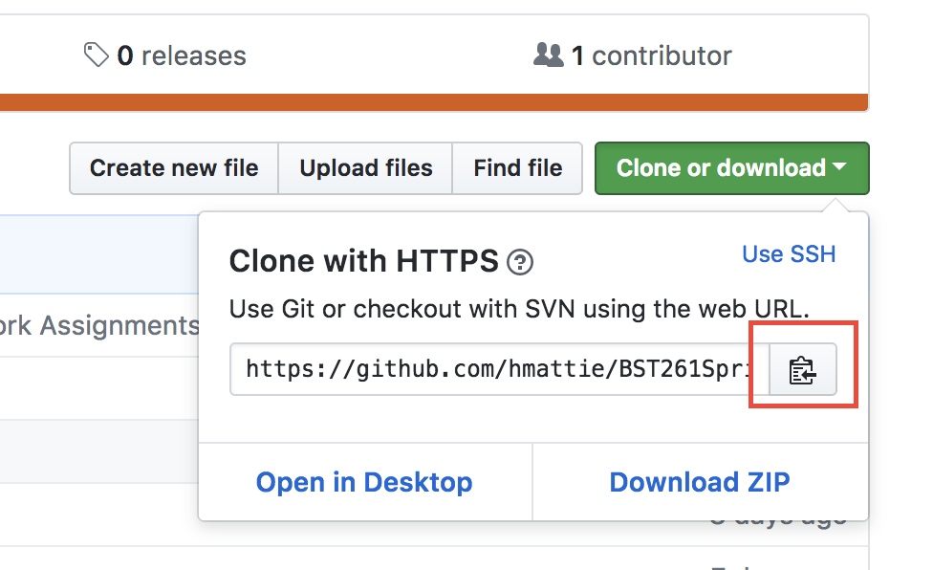

1. Go back to the terminal and type: “git clone” and then paste the repository link. Then press Enter.

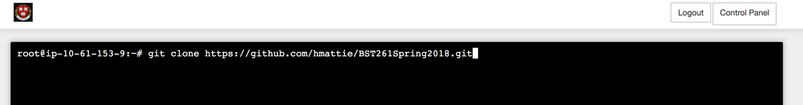

1. If you close the terminal window and go back to the JupyterHub window, you should now see a folder with the name of the repository. You can now access all of the Jupyter notebooks that have been uploaded to the course github.

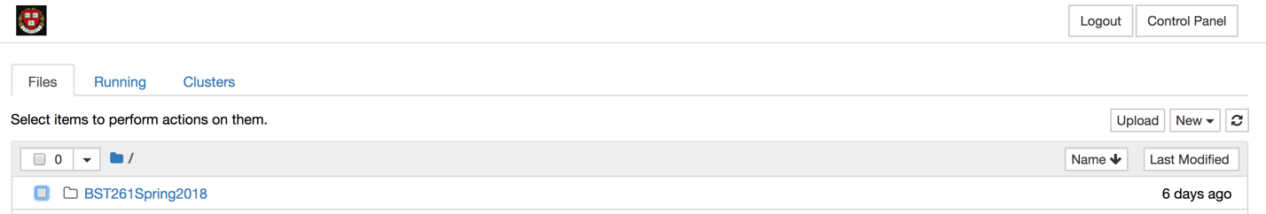

1. In order to have the most up to date versions of the files in the repository, you will need to update the folder in your JupyterHub. To do this, open terminal again, and type “git pull”. This will pull all of the new files on the course github and upload them to your JupyterHub. After that, you can close the terminal window and go back to your JupyterHub to access all of the new files.

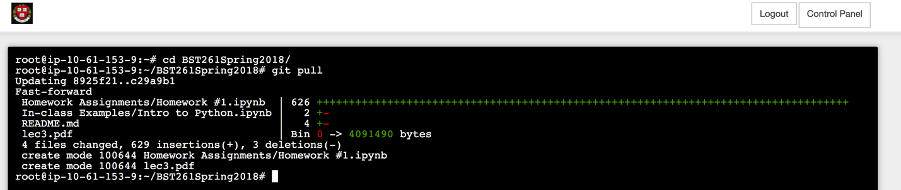

1. Something to note: if you make changes to any of the files in the folder and then later try to get the latest version of the files using “git pull”, it will give you an error. This is because you have altered the original files and if you upload the newest files, it will overwrite the files you have altered. Thus, git won’t let you upload any updated or new files. To get around this, create a new folder in your JupyterHub. For example: “BST261Copy”. Then, for any of the files you want to change (take notes in for example), select the file, and click “Duplicate”, and then “Duplicate” again when asked if you’re sure. This will make a copy of the file.

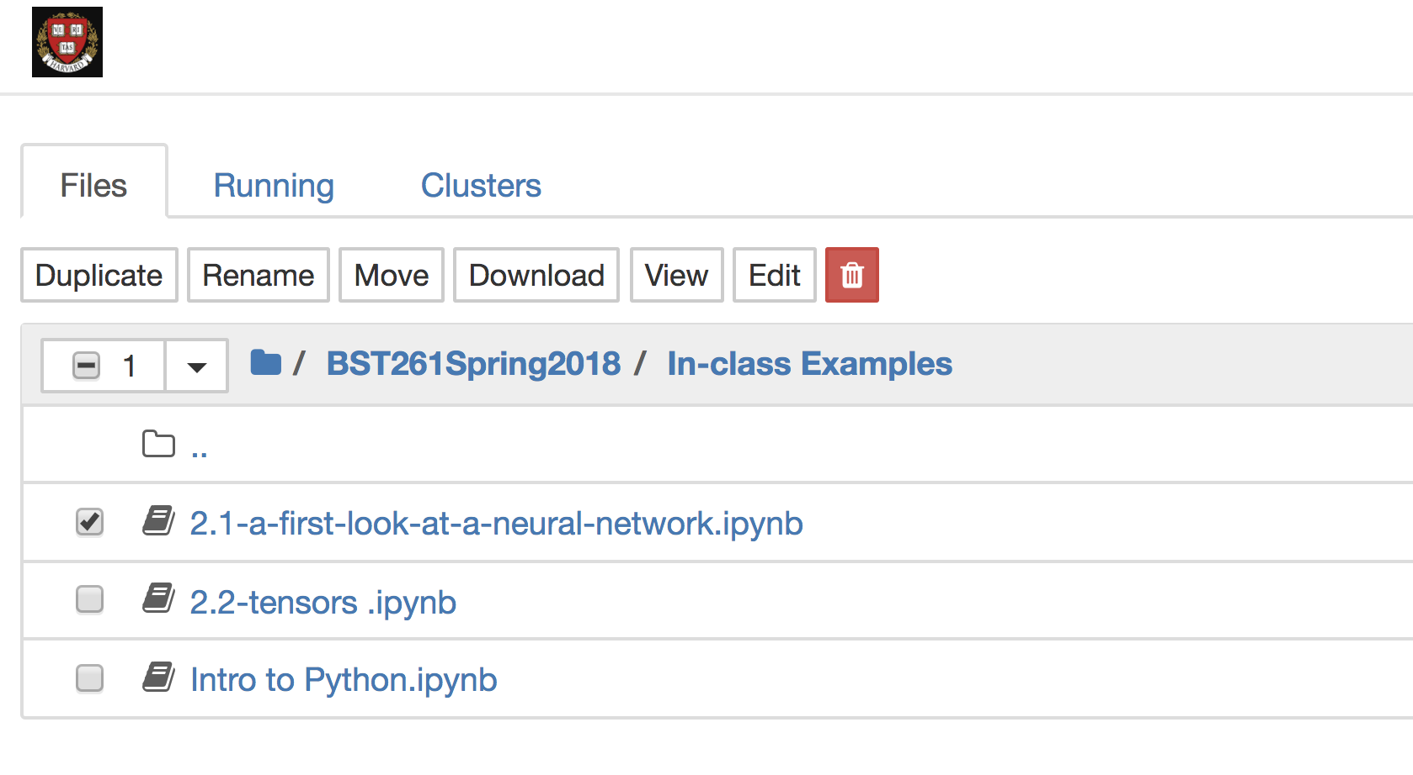

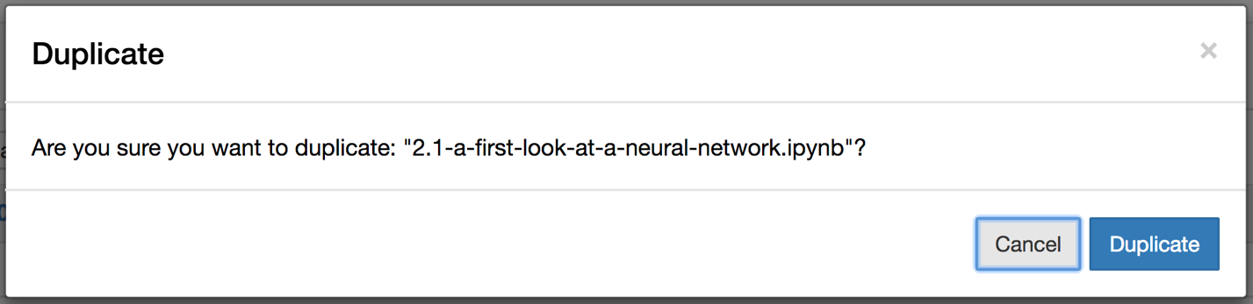

1. Now select the copy file you just created and click on “Move”. Erase the folder name and type the name of the new folder you created (ex: BST261Copy), and then click “Move” again. This will move the copied file into that folder. Now you can alter any files in the new folder, but keep the original files untouched. This way you won’t encounter an error when trying to pull the latest version of the course github repository.

